Country Information
1. Country identification and size of population | AT BE BG CY CZ DE DK EE EL ES  FI FR HU IE IS IT LI LT LU LV  MT NL NO PL PT RO SE SI SK UK  Population size: 4 700 000
Agency Information
2. Agency title and contact details | Name: Norwegian Medicines Agency  Address: Sven Oftedalsvei 6, N-0950 Oslo, Norway  Phone: 472289770 Fax: 22897799  E-mail: post@legemiddelverket.no
3. Head of Agency contact details | Please fill CV below on page 4.
4. Regular Representative at HMA Meetings | Please fill CV below on page 5 (if needed).
5. Contact Person for HMA Issues | Name:Gro Ramsten Wesenberg  Phone: 4722897701 Mobile: +4793099234 Fax: +4722897799  E-mail: gro.wesenberg@noma.no
6. Type of agency / entity | Independent body  General Directorate. Please specify which Ministry: Health and Care Serv  Other, please specify:
7. Date of establishment of the Agency | Date: 01.01.2001  Please provide any complementary information you may consider relevant:  Specialities Board for licencing from 1930, Norwegian Medicines Control Authority since 1974
8. Areas of competence

Human medicinal products
Veterinary medicinal products
Medical Devices
Cosmetics
Others
(please specify):

Information updated on:
09.05.2008
9. Responsibilities | Human |  |  |  |  |  | Veterinary |  |  |  | Medical Devices | Cosmetics
9. Responsibilities | Pharmacological (incl. chemical and biological/biotech) | Immunological | Homeopathic | Blood products | Herbals | Advanced therapies | Pharmacological | Immunological | Homeopathic | Blood products | Medical Devices | Cosmetics
Authorisation / registration
Clinical Trials / Investigation
Pharmacovigilance / Vigilance / Surveillance
Inspection /
Compliance
Quality Control
Batch release
Pricing
Health Technology Assessment (HTA) / Reimbursement
Regulatory and scientific advice
Information to patients
Information to healthcare professionals
Advertising control
Residues monitoring
Designation and supervision of Notified Bodies
Other (please specify)

Information updated on:
09.05.2008
Human Resources
10. Total Number of Employees:216 Full Time: 180 Part-Time: 36 Full-Time equivalence: 205
Outsourced activities:
11. Identification of Internal Experts | Total Number:
11. Identification of Internal Experts | Areas of Expertise / Number of Experts
11. Identification of Internal Experts | Quality 13 Pre-clinical 10 Clinical 19  Species 6 Inspections 9 Ecotoxicity  Residues 6 Pharmacovigilance 6  Others Please specify which: information 15
12. Identification of External Experts (including outsource) | Total Number:
12. Identification of External Experts (including outsource) | Areas of Expertise / Number of Experts
12. Identification of External Experts (including outsource) | Quality Pre-clinical 2 Clinical 19  Species Inspections Ecotoxicity  Residues Pharmacovigilance 8  Others Please specify which:
Funding
13. Funding | Budget (state budget) % of budget: 100  Fees (Industry fees/taxes) % of budget:  Other Please specify which:
14. Total of expenses (Euros) | 2006: 24 685 375 | 2007: 25 029 375
15. Total of revenues (Euros) | 2006: n.a | 2007: n.a
Activities
16. Mission of the organisation (max. 200 characters):
Visible and active promoter of animal and human public health

17. Complementary information | In the case you may consider it useful, please provide complementary information which could clarify any of the issues mentioned above or any specific understanding of your agency on any specific issue or activity (max 200 characters):  The fees from the pharmaceutical industry goes back to the Ministry of finance, and is not relevant for our budget  Lab.control, reimbursement and pricing not included in Q 11. .

Name of the person responsible for completing this questionnaire: | Gro Ramsten Wesenberg | Information updated on:  09.05.2008
Head of Agency
Curriculum Vitae

Name of Head of Agency: |  |  |  | 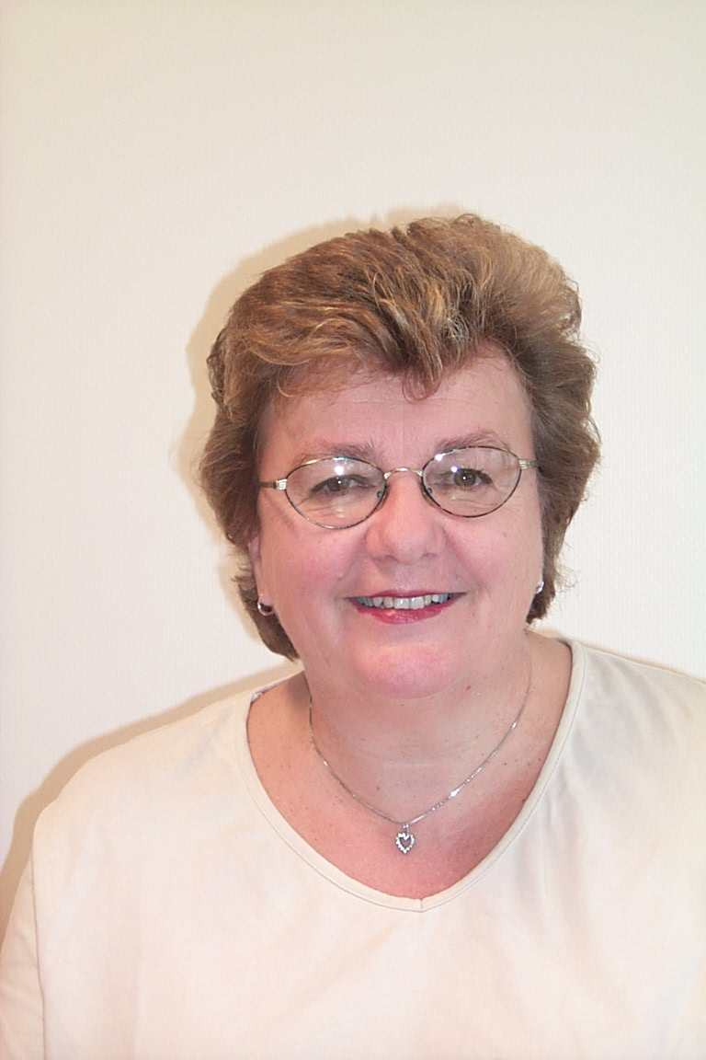
Gro Ramsten Wesenberg
Academic / Professional title: |  | DDS, PhD
Name of Agency: | Norwegian Medicines Agency

Country:
AT BE BG CY CZ DE DK EE EL ES FI FR HU IE IS
IT LI LT LU LV MT NL NO PL PT RO SE SI SK UK

Contact details:
Address: Sven Oftedalsvei 6, N-0950 Oslo, Norway
Telephone: + 4722897701 Mobile: +4793099234 Fax: +4722897799
E-mail: gro.wesenberg2noma.no

Years within the agency: | 15

Education (Institution, area/field pf expertise, country, date) (max. 300 characters)::
1971 DDS, University of Bergen, Norway; 1983 PhD (toxicology), Faculty of Medicine, University of Bergen, Norway
Crossing the boundaries (leadership raining),2001 (Danish Scool of Public administation)
Approx 35 postgrad courses in various fields.

Professional experience
(Institution/company, country, position, date. Please provide only information on your current and last 2 jobs). (max. 400 characters):
1974-1993. University of Bergen: Associate professor in Human Anatomy (Medical faculty), Clinical instructor in cariology and endodontics (Dental Faculty)
1993- Norwegian Medicines Agency: Clinical assessor, Director of Medical Department, Director General and Head of Agency since 1999

Specialisation
Please provide details (max. 300 characters):

Member of any HMA Working Group: | HMA/EMEA Training Project Team (chair) | Information updated on:  09.05.2008

