Country Information
1. Country identification and size of population | AT BE BG CY CZ DE DK EE EL ES  FI FR HU IE IS IT LI LT LU LV  MT NL NO PL PT RO SE SI SK UK  Population size: 10 570 000
Agency Information
2. Agency title and contact details | Name: Federal Agency for Medicines and Health Products  Address: Place Victor Horta 40, bte 40, 1060 Brussels  Phone: +32/2-524-80-05 Fax: +32/2-524-80-03  E-mail: management@fagg.be
3. Head of Agency contact details | Please fill CV below on page 4.
4. Regular Representative at HMA Meetings | Please fill CV below on page 5 (if needed).
5. Contact Person for HMA Issues | Name: Els Geeraerts  Phone: +32/2-524-80-25 Mobile: +32/0479-97-22-76 Fax: +32/2-524-80-03  E-mail: els.geeraerts@fagg.be
6. Type of agency / entity | Independent body  General Directorate. Please specify which Ministry:  Other, please specify:
7. Date of establishment of the Agency | Date: 1-1-2007  Please provide any complementary information you may consider relevant:  Before: directorate general of the public service public health
8. Areas of competence

Human medicinal products
Veterinary medicinal products
Medical Devices
Cosmetics
Others
(please specify): Cells, Tissues and Blood

Information updated on:
03-28-12
9. Responsibilities | Human |  |  |  |  |  | Veterinary |  |  |  | Medical Devices | Cosmetics
9. Responsibilities | Pharmacological (incl. chemical and biological/biotech) | Immunological | Homeopathic | Blood products | Herbals | Advanced therapies | Pharmacological | Immunological | Homeopathic | Blood products | Medical Devices | Cosmetics
Authorisation / registration
Clinical Trials / Investigation
Pharmacovigilance / Vigilance / Surveillance
Inspection /
Compliance
Quality Control
Batch release
Pricing
Health Technology Assessment (HTA) / Reimbursement
Regulatory and scientific advice
Information to patients
Information to healthcare professionals
Advertising control
Residues monitoring
Designation and supervision of Notified Bodies
Other (please specify) | blood, cells and tissues: donation, traceability, recognition banks, pricing of blood etc…

Information updated on:
03-28-12
Human Resources
10. Total Number of Employees:388 Full Time:280 Part-Time: 109 Full-Time equivalence:346,32
Outsourced activities:
11. Identification of Internal Experts | Total Number:
11. Identification of Internal Experts | Areas of Expertise / Number of Experts
11. Identification of Internal Experts | Quality 15 Pre-clinical 7 Clinical 13  Species 5 Inspections / Ecotoxicity 0, 25  Residues 0, 25 Pharmacovigilance 13  Others Please specify which:
12. Identification of External Experts (including outsource) | Total Number:
12. Identification of External Experts (including outsource) | Areas of Expertise / Number of Experts
12. Identification of External Experts (including outsource) | Quality 20 Pre-clinical 2 Clinical 200  Species 50 Inspections 8 Ecotoxicity /  Residues / Pharmacovigilance 1  Others Please specify which:
Funding
13. Funding | Budget (state budget) % of budget: 34,6  Fees (Industry fees/taxes) % of budget: 65,4  Other Please specify which:
14. Total of expenses (Euros) | 2010: 53.508.758 | 2011: 56.616.513
15. Total of revenues (Euros) | 2010: 53.508.758 | 2011: 56.616.514
Activities
16. Mission of the organisation (max. 200 characters):
ensure to the community the quality, safety and efficacy of medicinal products in the broader sense, as well as from all performed operations involving blood, cells and tissues
·

17. Complementary information | In the case you may consider it useful, please provide complementary information which could clarify any of the issues mentioned above or any specific understanding of your agency on any specific issue or activity (max 200 characters):

Name of the person responsible for completing this questionnaire: | Christine Guérin | Information updated on:  03-28-12

Head of Agency

Curriculum Vitae

Name of Head of Agency: |  |  |  | 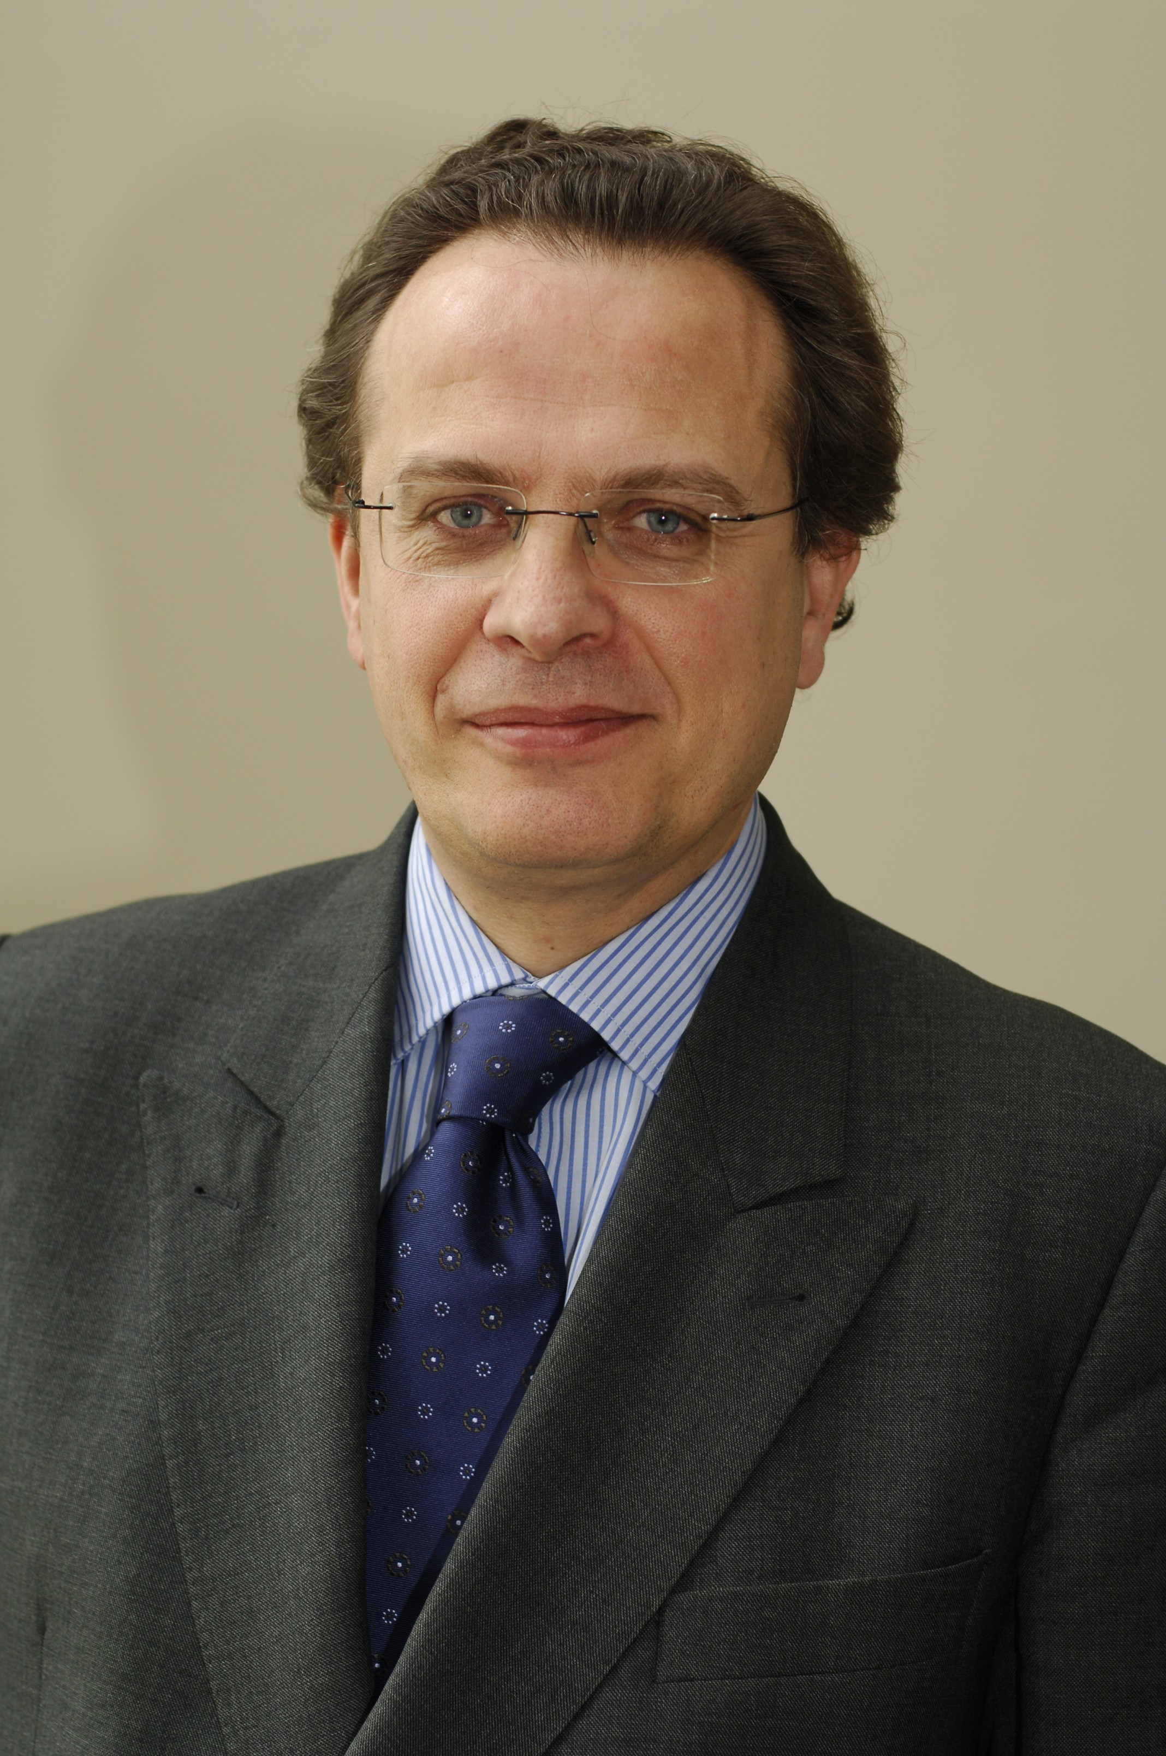
Xavier De Cuyper
Academic / Professional title: |  | Chief Executive Officer
Name of Agency: | Agency for Medicines and Health Products

Country:
AT BE BG CY CZ DE DK EE EL ES FI FR HU IE IS
IT LI LT LU LV MT NL NO PL PT RO SE SI SK UK

Contact details:
Address: Place Victor Horta 40/40, 1060 BRUSSELS, BELGIUM
Telephone: +32/2-524-84-00 Mobile: Fax: +32/2-524-80-03
E-mail: xavier.decuyper@fagg.be

Years within the agency: | 5

Education (Institution, area/field pf expertise, country, date) (max. 300 characters)::
1980: degree in agricultural engineering, magna cum laude, (department of general agronomy) at the Faculty of Agricultural Sciences (Faculté des Sciences Agronomiques) of the Catholic University of Louvain (UCL)

Professional experience
(Institution/company, country, position, date. Please provide only information on your current and last 2 jobs). (max. 400 characters):
Before September 2003: Federal Public Services (SPF) and Federal Agency for the Security of the Food Chain (AFSCA)
September 2003 - April 2007 : Director of the Cabinet of the Vice-Prime Minister
Since 1st of May 2007: Chief Executive Officer of the Federal Agency for Medicines and Health Products (Belgium)

Specialisation
Please provide details (max. 300 characters):

Member of any HMA Working Group: | Mentor of CTFG | Information updated on:  03-28-12

Regular Representative at HMA Meetings
Curriculum Vitae

Name of the regular representative at HMA meetings:
Academic / Professional title: |  | Xavier De Cuyper
Name of Agency: | Agency for Medicines and Health Products

Country:
AT BE BG CY CZ DE DK EE EL ES FI FR HU IE IS
IT LI LT LU LV MT NL NO PL PT RO SE SI SK UK

Contact details:
Address: Place Victor Horta 40/40, 1060 BRUSSELS, BELGIUM
Telephone: +3225248400 Mobile: Fax: +3225248003
E-mail: xavier.decuyper@fagg.be

Years within the agency: | 5

Education (Institution, area/field pf expertise, country, date) (max. 300 characters)::
Idem previous CV of Xavier De Cuyper

Professional experience
(Institution/company, country, position, date. Please provide only information on your current and last 2 jobs). (max. 400 characters):
Idem previous CV of Xavier De Cuyper

Specialisation
Please provide details (max. 300 characters):

Member of any HMA Working Group: |  | Information updated on:  03-28-12

